1. **Aim:** To Design Deterministic Finite Automata using simulator to accept the input string “a” , ”ac”, and ”bac”.

**Diagram:**

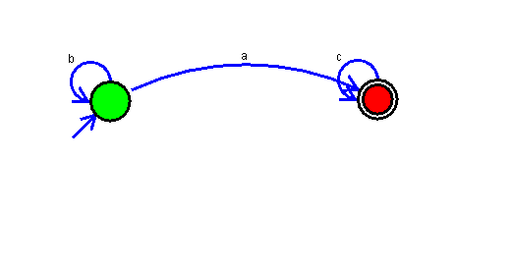

**Result:**

Thus, successfully executed Deterministic Finite Automata using simulator to accept the input string “a” ,”ac”, and ”bac”.